Gulf of Mexico Marine Assessment Program for Protected Species (GoMMAPPS):
Seabirds Project Overview

BACKGROUND: The Gulf of Mexico (GoM) region is critically important in affording breeding, staging, and wintering habitats for North America’s migratory avian resources. Unfortunately, limited information is available to quantitatively characterize species composition, distribution, and abundance of birds Gulfwide, and particularly for seabirds. The number of platforms and cumulative level of oil and gas activity in the northern GoM region exceeds all other Bureau of Ocean Energy Management regions combined. As a result, such information is important for assisting decision-making related to offshore resource extraction in an effort to mitigate potential effects to avian resources.
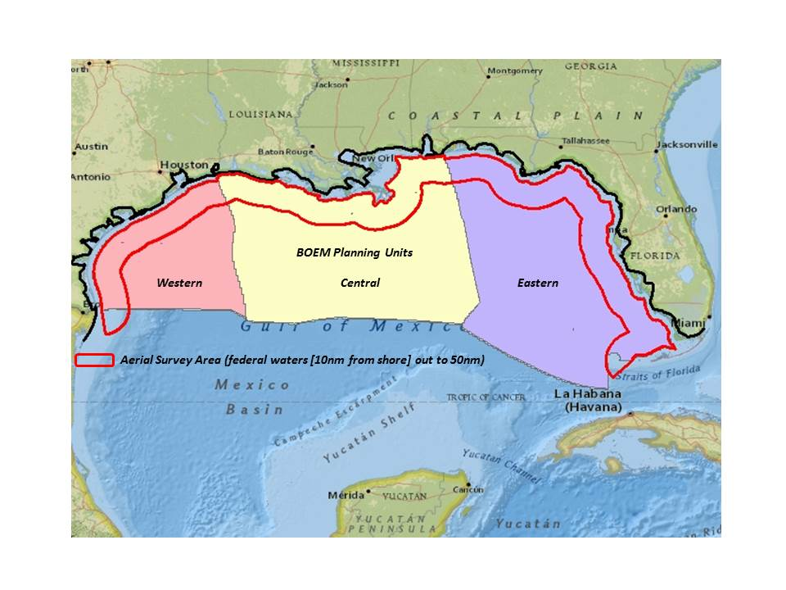
OBJECTIVES: The GoMMAPPS Seabird Project is anticipated to be the most spatially and temporally extensive avian research effort in the northern GoM, intended to document the distribution, abundance, and diversity of birds for the purposes of better informing regulatory decisions that influence the conservation of migratory birds. A key component of this project includes identifying and determining how natural and anthropogenic variables of the northern GoM influence avian species in nearshore and pelagic environments of this region.
THE PROJECT: There are two main components of the GoMMAPPS Seabird Project: (1) Design and implementation of aerial and vessel-based surveys to collect information characterizing the distribution, abundance, and diversity of birds in the northern GoM; and (2) Using models and other empirical data to interpret the influences of natural and anthropogenic variables on avian species. The project will evaluate the null model that avian populations are not influenced by: presence and status of offshore oil and gas platforms; proximal fisheries activities; proximal micro-habitat or forage indicators; oceanographic features; and broad scale weather patterns.
Figure 1. Spatial bounds of seabird surveys within northern Gulf of Mexico.
Aerial-based surveys will take place from the nearshore environment out to ~50 nautical miles (see Figure 1), during summer and winter seasons. These surveys will be conducted using USFWS Kodiak amphibious aircraft and span the entirety of the northern GoM from the Texas-Mexico border to the Florida Keys. Vessel-based surveys (2 seabird observers/vessel/leg) will be conducted cooperatively with NOAA staff on vessels conducting annual fisheries and plankton surveys, as well as on a dedicated NOAA vessel for conducting marine mammal surveys. These combined efforts should provide nearly complete coverage of the entire northern GoM out to the EEZ (refer to Figure 1).
TIMELINE & DELIVERABLES: The project will take place from 2016 – 2020, with implementation of surveys scheduled for 2017 – 2019. A Final Report including analyses of all data collected from aerial and seabird surveys, spatially-explicit Decision Support Tools, relevant models (and code), maps, and a database will be provided to BOEM at the end of this project.
CONTACT:

Jeffrey S. Gleason, PhD
U.S. Fish & Wildlife Service
Gulf of Mexico Migratory Bird Coordinator
Gulf Restoration Team
Office Phone: (985)882-2010
E-mail: jeffrey_gleason@fws.gov
Randy Wilson
Station Leader, Migratory Bird Field Office
U.S. Fish and Wildlife Service
Office: (601) 965-4903, ext. 300
Email: randy_wilson@fws.gov

